
CC-215-L: Database Systems Lab

Faculty of Computing & Information Technology

BS(IT-24)
LAB – 04
The objective of this lab is to:
- Window Functions
- Joins
- Previous SQL Content
COURSE & LAB INSTRUCTOR: Dr. Asif Sohail
LAB TIMING : 90 MINS
TOTAL MARKS : 45
Task 01: [15 marks]
- Display the employee's name along with the name of their manager. For employees who do not have a manager, display NULL in place of the manager’s name.
SELECT E.ENAME ENAME, M.ENAME MANAGER_NAME FROM EMP E LEFT OUTER JOIN EMP M ON M.EMPNO = E.MGR
- Display the name, salary grade, and job title of all employees whose job is ‘MANAGER’, based on the salary range defined in the SALGRADE table.

SELECT ENAME, SALGRADE.GRADE,JOB FROM EMP
JOIN SALGRADE ON EMP.SAL BETWEEN SALGRADE.LOSAL AND SALGRADE.HISAL
WHERE JOB = 'MANAGER'

- Write an SQL query to display the name of the manager and number of employees working under each manager.
SELECT
M.ENAME AS Manager_Name,
COUNT(E.EMPNO) AS Number_of_Employees
FROM EMP E
JOIN EMP M
ON E.MGR = M.EMPNO
GROUP BY M.ENAME;

- Display each employee’s employee number, name, department number, and salary, along with their salary rank within the department, where the highest-paid employee in each department has rank 1.
SELECT
EMPNO,
ENAME,
DEPTNO,
SAL,
RANK() OVER (PARTITION BY DEPTNO ORDER BY SAL DESC) AS Salary_Rank
FROM EMP;

- Write the query to find employees who earn more than the average salary of their department.
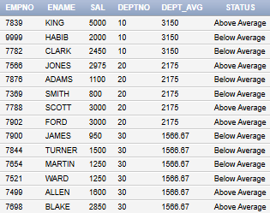
SELECT EMPNO, ENAME, SAL, DEPTNO,
ROUND(AVG(SAL) OVER (PARTITION BY DEPTNO),2) AS DEPT_AVG,
CASE
WHEN SAL > AVG(SAL) OVER (PARTITION BY DEPTNO) THEN 'Above Average'
WHEN SAL < AVG(SAL) OVER (PARTITION BY DEPTNO) THEN 'Below Average'
ELSE 'Equal to Average'
END AS STATUS
FROM EMP;
- Write an SQL query to retrieve employees whose salaries do not fall within the ranges specified in the salgrade table. Display their grade as “F”.
SELECT DISTINCT EMPNO, ENAME, SAL, DEPTNO,NVL(TO_CHAR(G.GRADE), 'F') AS GRADE
FROM EMP A
LEFT JOIN SALGRADE G ON A.SAL BETWEEN G.LOSAL AND G.HISAL
ORDER BY NVL(TO_CHAR(G.GRADE), 'F')

- Use the window function to find the second lowest salary in the whole organization .
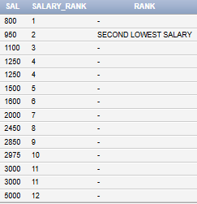
SELECT sal, DENSE_RANK() OVER (ORDER BY sal ASC) as salary_rank,CASE
WHEN DENSE_RANK() OVER (ORDER BY sal ASC)= 2 THEN 'SECOND LOWEST SALARY'
ELSE ''
END AS RANK
FROM EMP

- Display the employee names along with the name of departments they work in.

SELECT
E.ENAME AS Employee_Name,
D.DNAME AS Department_Name
FROM EMP E
JOIN DEPT D
ON E.DEPTNO = D.DEPTNO;

- Get such Employees who have no manager (You must use join).
(Hint: You can join emp with itself)

SELECT
E.ENAME AS Employee_Name,
M.ENAME AS Manager_Name
FROM EMP E
LEFT JOIN EMP M
ON E.MGR = M.EMPNO
WHERE M.ENAME IS NULL;

- Display the name of the employee along with the location of the department work in

SELECT
E.ENAME AS Employee_Name,
D.LOC AS Department_Location
FROM EMP E
JOIN DEPT D
ON E.DEPTNO = D.DEPTNO;
Task 02: [16 marks]

- Include a query that compares the sal of each employee with the average sal of the employees with same job. The output is ename, job, sal, avg-sal, status.
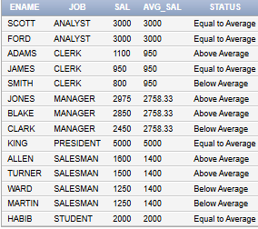
SELECT
ename,
job,
sal,
ROUND(AVG(sal) OVER (PARTITION BY job), 2) AS avg_sal,
CASE
WHEN sal > AVG(sal) OVER (PARTITION BY job) THEN 'Above Average'
WHEN sal < AVG(sal) OVER (PARTITION BY job) THEN 'Below Average'
ELSE 'Equal to Average'
END AS status
FROM emp
ORDER BY job, sal DESC;

- Display each employee’s name, their manager’s name, department name, salary, and the difference between their salary and the department’s average salary

SELECT
E.ENAME AS Employee_Name,
M.ENAME AS Manager_Name,
D.DNAME AS Department_Name,
E.SAL AS Salary,
ROUND(E.SAL - AVG(E.SAL) OVER (PARTITION BY E.DEPTNO), 2) AS Diff_From_Dept_Avg
FROM EMP E

- Display the average salary for each salary grade, but include only those grades where the average salary is greater than 1500.The result should show the salary grade and its average salary, sorted in ascending order of salary grade.

SELECT S.GRADE AS Salary_Grade,
ROUND(AVG(E.SAL), 2) AS Average_Salary
FROM EMP E
JOIN SALGRADE S
ON E.SAL BETWEEN S.LOSAL AND S.HISAL
GROUP BY S.GRADE
HAVING AVG(E.SAL) > 1500
ORDER BY S.GRADE ASC;

- Display Jobs with total number of hirings.
SELECT
JOB,
COUNT(*) AS TOTAL_HIRINGS
FROM
EMP
GROUP BY
JOB
ORDER BY
TOTAL_HIRINGS DESC;

- List the employees based on the number of vowels in their names, with the employee having the highest number of vowels ranked first.
SELECT
ENAME,
(LENGTH(ENAME) - LENGTH(
REPLACE(
REPLACE(
REPLACE(
REPLACE(
REPLACE(UPPER(ENAME), 'A', ''),
'E', ''),
'I', ''),
'O', ''),
'U', '')
)) AS VOWEL_COUNT,
RANK() OVER (ORDER BY
(LENGTH(ENAME) - LENGTH(
REPLACE(
REPLACE(
REPLACE(
REPLACE(
REPLACE(UPPER(ENAME), 'A', ''),
'E', ''),
'I', ''),
'O', ''),
'U', '')
)) DESC
) AS RANK_BY_VOWELS
FROM
EMP
ORDER BY
VOWEL_COUNT DESC;

- ⦁ Display each department number, along with a list of all job titles present in that department and the total salary earned by employees in that department, sorted in ascending order of department number

SELECT DEPTNO, LISTAGG(JOB, ' / ') WITHIN GROUP (ORDER BY JOB) AS Jobs, SUM(SAL) AS Total_Salary FROM EMP GROUP BY DEPTNO ORDER BY DEPTNO;

- Return the maximum average salary of the department.
SELECT
MAX(AVG(SAL)) AS Max_Avg_Salary
FROM EMP
GROUP BY DEPTNO;

- Display each employee’s name, department number, job title, and salary.
Along with that, show:
- their rank within the department based on salary,
- their overall company rank based on salary, and
- their seniority within their job based on hire date.
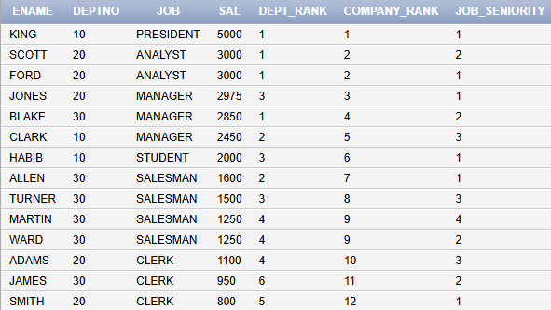
SELECT
ENAME,
DEPTNO,
JOB,
SAL,
RANK() OVER (PARTITION BY DEPTNO ORDER BY SAL DESC) AS Dept_Rank,
DENSE_RANK() OVER (ORDER BY SAL DESC) AS Company_Rank,
ROW_NUMBER() OVER (PARTITION BY JOB ORDER BY HIREDATE ASC) AS Job_Seniority
FROM EMP;

- Find the employee with the third highest salary in each department.

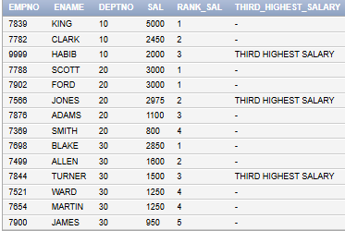
SELECT
EMPNO,
ENAME,
DEPTNO,
SAL,
DENSE_RANK() OVER (PARTITION BY DEPTNO ORDER BY SAL DESC) AS RANK_SAL,
CASE
WHEN RANK() OVER (PARTITION BY DEPTNO ORDER BY SAL DESC) = 3
THEN 'THIRD HIGHEST SALARY'
END AS THIRD_HIGHEST_SALARY
FROM EMP
ORDER BY DEPTNO, SAL DESC;

- Display each department’s total salary, average salary, highest salary, and number of employees, along with the department’s rank based on total salary.
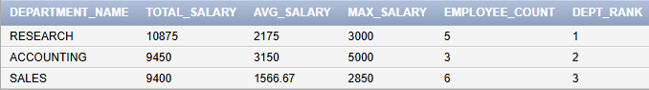
SELECT
D.DNAME AS Department_Name,
SUM(E.SAL) AS Total_Salary,
ROUND(AVG(E.SAL),2) AS Avg_Salary,
MAX(E.SAL) AS Max_Salary,
COUNT(*) AS Employee_Count,
RANK() OVER (ORDER BY SUM(E.SAL) DESC) AS Dept_Rank
FROM EMP E
JOIN DEPT D ON E.DEPTNO = D.DEPTNO
GROUP BY D.DNAME;

Task 03: [9 marks]
- Write a query that lists departments and, for each department, concatenates the names of employees who have salaries above the department's average salary. The concatenated list should be sorted by the reverse alphabetical order of the employee names, and all names should be converted to lowercase. If there are no employees with salaries above the average for that department, display "NO HIGH SALARY EMPLOYEES" for that department.
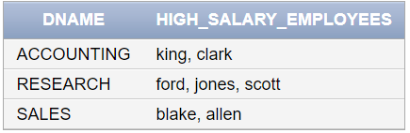
SELECT d.deptno,
NVL(
LISTAGG(LOWER(e.ename), ' / ')
WITHIN GROUP (ORDER BY e.ename DESC),
'no high salary employees'
) AS high_salary_employees
FROM emp e
JOIN dept d ON e.deptno = d.deptno
WHERE e.sal > (SELECT AVG(sal) FROM emp WHERE deptno = e.deptno)
GROUP BY d.deptno
ORDER BY d.deptno;

- Write a SQL query to display each employee’s name, job title, department name, manager’s name, salary, and commission (if any).
Additionally, show:
- Their position rank within the entire company based on salary using a window function.
- Their rank within their department based on salary.
- Their total earnings (salary + commission, treating nulls as 0).
- The percentage contribution of each employee’s salary to their department’s total salary.
- The length of their name, reversed name, and a formatted label like "KING - PRESIDENT (DEPT: ACCOUNTING)".
SELECT
E.ENAME AS EMPLOYEE_NAME,
E.JOB AS JOB_TITLE,
D.DNAME AS DEPARTMENT_NAME,
M.ENAME AS MANAGER_NAME,
E.SAL AS SALARY,
E.COMM AS COMMISSION,
RANK() OVER (ORDER BY E.SAL DESC) AS COMPANY_RANK,
RANK() OVER (PARTITION BY E.DEPTNO ORDER BY E.SAL DESC) AS DEPT_RANK,
E.SAL + NVL(E.COMM, 0) AS TOTAL_EARNINGS,
ROUND(E.SAL / SUM(E.SAL) OVER (PARTITION BY E.DEPTNO) * 100, 2) AS SALARY_PERCENTAGE,
LENGTH(E.ENAME) AS NAME_LENGTH,
REVERSE(E.ENAME) AS REVERSED_NAME,
E.ENAME || ' - ' || E.JOB || ' (DEPT: ' || D.DNAME || ')' AS FORMATTED_LABEL
FROM EMP E
LEFT JOIN EMP M ON E.MGR = M.EMPNO
LEFT JOIN DEPT D ON E.DEPTNO = D.DEPTNO
ORDER BY E.SAL DESC;

- For each department in the company, write an Oracle SQL query to display:
  - Department number.
  - Total salary expense of the department.
  - Average salary of the department (rounded to 2 decimal places).
  - Maximum salary in the department.
  - The difference between the department’s average salary and the company-wide average salary, formatted as:
  - +value if the department average is above the company average,
  - -value if below,
  - 0 if equal
  - Rank of the department based on average salary, with the highest average ranked first.
SELECT
DEPTNO AS DEPARTMENT_NO,
SUM(SAL) AS TOTAL_SALARY_EXPENSE,
ROUND(AVG(SAL),2) AS AVG_DEPT_SALARY,
MAX(SAL) AS MAX_SALARY,
CASE
WHEN AVG(SAL) > AVG(AVG(SAL)) OVER () THEN '+' || ROUND(AVG(SAL) - AVG(AVG(SAL)) OVER (),2)
WHEN AVG(SAL) < AVG(AVG(SAL)) OVER () THEN '-' || ROUND(AVG(AVG(SAL)) OVER () - AVG(SAL),2)
ELSE '0'
END AS DIFF_FROM_COMPANY_AVG,
RANK() OVER (ORDER BY AVG(SAL) DESC) AS DEPT_RANK_BY_AVG_SAL
FROM EMP
GROUP BY DEPTNO
ORDER BY DEPT_RANK_BY_AVG_SAL;

Task 04: [5 marks]
VIVA VOCE

